**2021:**

1. Using the Algorithm for Testing Nonadditive (Lossless) Join property, test if the decomposition of R into {R1,..,R5} is a lossless join decomposition.

Let R = ABCDE, R1 = AD, R2 = AB, R3 = BE, R4 = CDE, and R5 = AE.

Let the functional dependencies be: A →C, B →C, C → D, DE→C, CE→A

Solution: <https://youtu.be/3NRRAga6YVw>

1. Consider the universal relation R = {A, B, C, D, E, F, G, H, I, J} and the set of functional dependencies,F = { {A, B}🡪{C}, {A}🡪{D, E}, {B}🡪{F}, {F}🡪{G, H}, {D}🡪{I, J}}

What is the key for R? Decompose R into 2NF and then into 3NF relations.

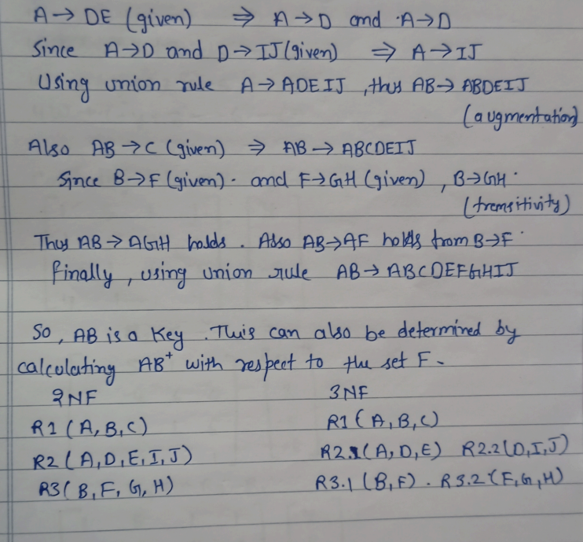

1. Write a algorithm to find the minimal cover F for a set of functional dependencies? Explain with an example

**2020**

1.Consider a relation *R*(*A*, *B*, *C*, *D*, *E*) with the following dependencies: *AB🡪 C*, *CD🡪 E*, *DE🡪B* Determine the candidate keys of this relation

2.Define MVD and explain 4NF related to it with an example.

3.A set of FDs for the relation R {A, B, C, D} E:{B->A, D->A,AB->D}.

Find a minimum cover for this set of FDs illustrating all the inferences used.

4.Given the relation r(R). State whether the following functional dependencies are satisfied by the relation or not.

i) A*🡪* B ii) AB *🡪 C iii) C 🡪 A iv) BC 🡪 A*

| A | B | C |
| --- | --- | --- |
| 1 | 4 | 2 |
| 3 | 5 | 6 |
| 3 | 4 | 6 |
| 7 | 3 | 8 |
| 9 | 1 | 0 |

**2019:**

1.Given below are two sets of FunctIonal dependencies for a relation R(A, B, C). Prove that they are equivalent

F1 = { A 🡪B, B🡪C, C🡪A}

F2 = { A 🡪C, C🡪B, B🡪A}

2.What is functional dependency? How is it used in bringing relation

into second Normal form? Why "null" values are considered bad in

Relation?

3.Consider the relation R with four attributes ABCD, with the following sets of FD's

C🡪D, C🡪A, B🡪C

i) Identify the candidate key(s) for R.

ii) Indentify the best normal form that R satisfies

(1NF, 2NF, 3NF, or BCNF)

iii) If R is not in BCNF, decompose it into a set of BCNF relations that preserve the dependencies

**2018:**

1.Discuss the different types of anomalies in handling the relations with an example.

2.Define functional dependency. Write an algorithm to find the closure of given functional dependency.

3.What do you mean by equivalence of functional dependencies? Given the following set of functional dependency check whether they are equivalent or not.

Relation R = (A, B, C, D, E, F)

F 1 = { A → C , AC → D , E → AD , E → F }

F 2 = { A → CD, E → AF }

4.Define minimal cover of set of functional dependency. Write an algorithm to find the minimal cover set of the functional dependency.